**Issue with BRIDG Mapping Spreadsheet Error on Windows 10**

I (Julie E) had this issue when using the BRIDG mapping spreadsheet on Windows 10. When I tried the same thing on my Windows 7 machine, the issue didn’t occur. Wendy, who was also using Windows 7, didn’t have the issue either.

What happened: I added several new rows to the Mapped Specification Source and then clicked on “Initialize/Update” in the Setup tab of the mapping spreadsheet. I received the following VB error, as shown in the screenshot below:

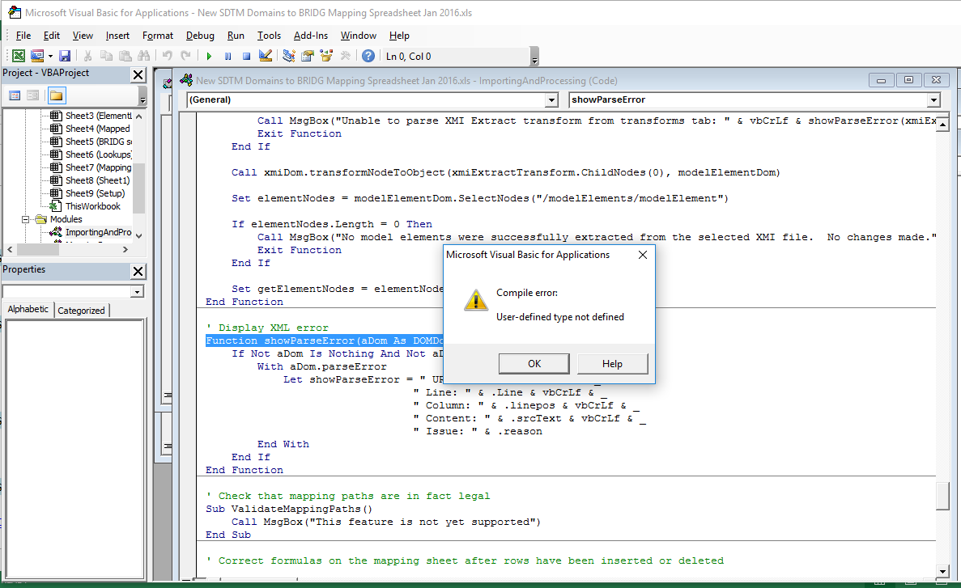

Also, when looking at the Mappings spreadsheet tab, there are display errors, as shown in the screenshot below:

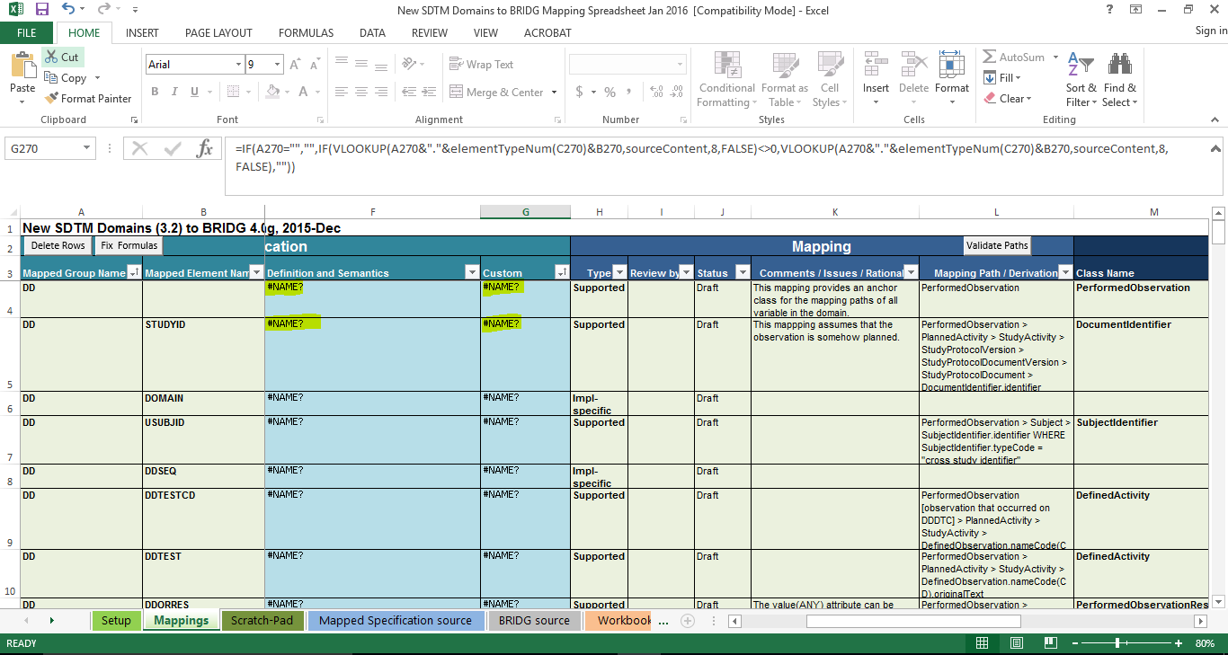

Wendy contacted Lloyd McKenzie, the author of the VB code for the spreadsheet, and he first suggested to download MSXML: “It looks like she may not have MSXML installed on her machine.  You can get it here: <https://www.microsoft.com/en-ca/download/details.aspx?id=15697>”.

So I downloaded and installed it, but still had the same problem. Lloyd agreed to have a telecon to discuss and in 10 minutes, figured out a workaround that is documented below. He didn’t know why my machine shows that it has XML 6.0 loaded and then gives an error message, but essentially what we did was change the code to work with XML 4.0, which solved the problem.

**Workaround:**

1. When the error occurs, select “Tools” then “References” from the Microsoft Visual Basic for Applications Menu and unclick “Microsoft XML, v6.0”.

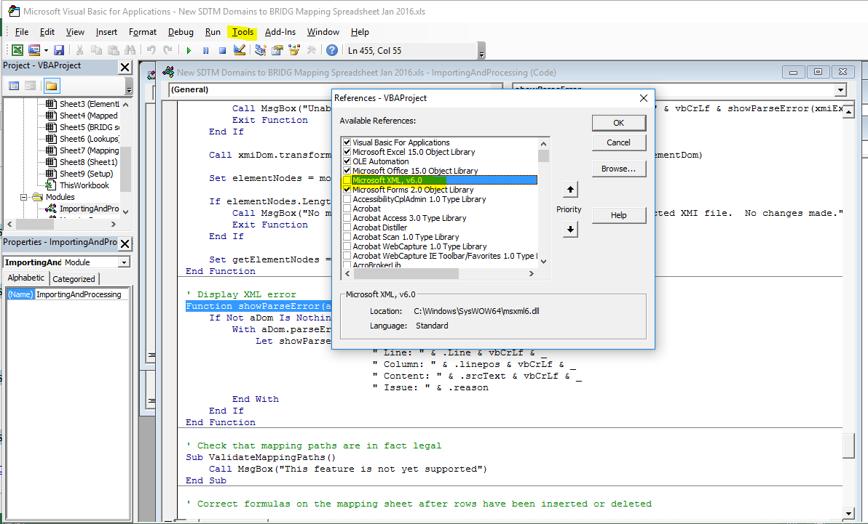

1. Then, scroll down to “Microsoft XML, v4.0” and click on that to select it.

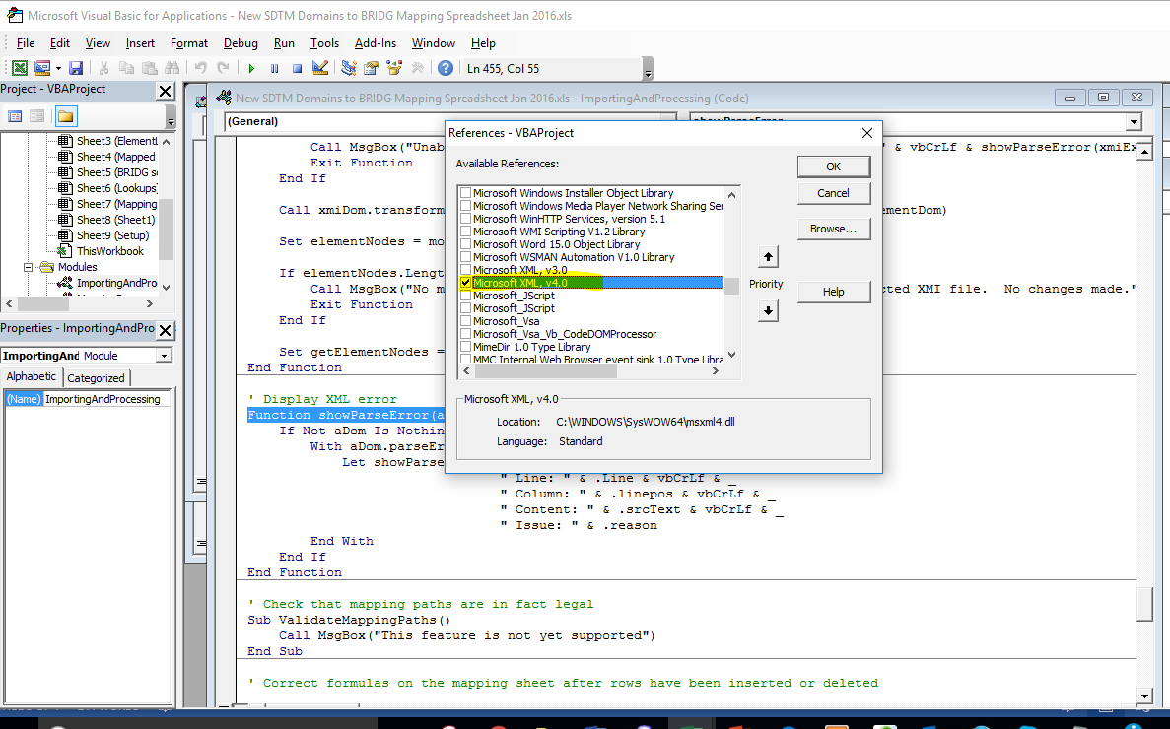

1. Then, find and replace all the occurrences of “DOMDocument60” with “DOMDocument40”. On the “Find and Replace” window, click on “Current Project” under “Search”. There should be 3 replacements made.

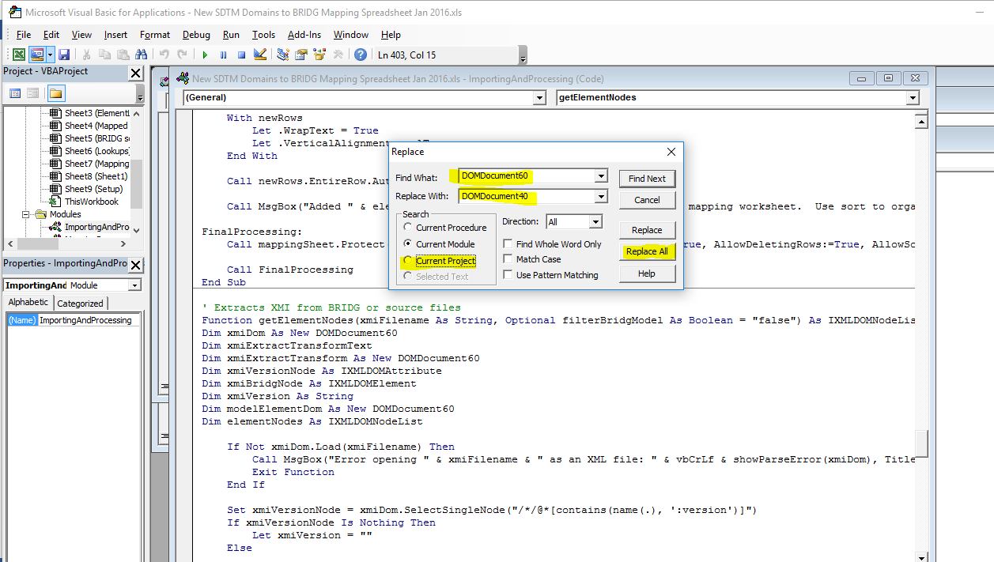

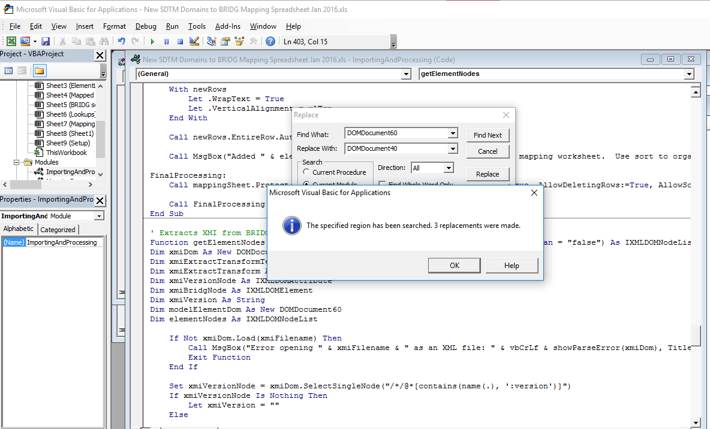

1. Then, from the Microsoft Visual Basic for Applications menu, select Debug, then Compile as shown in Exhibit 6.

**Exhibit 6**

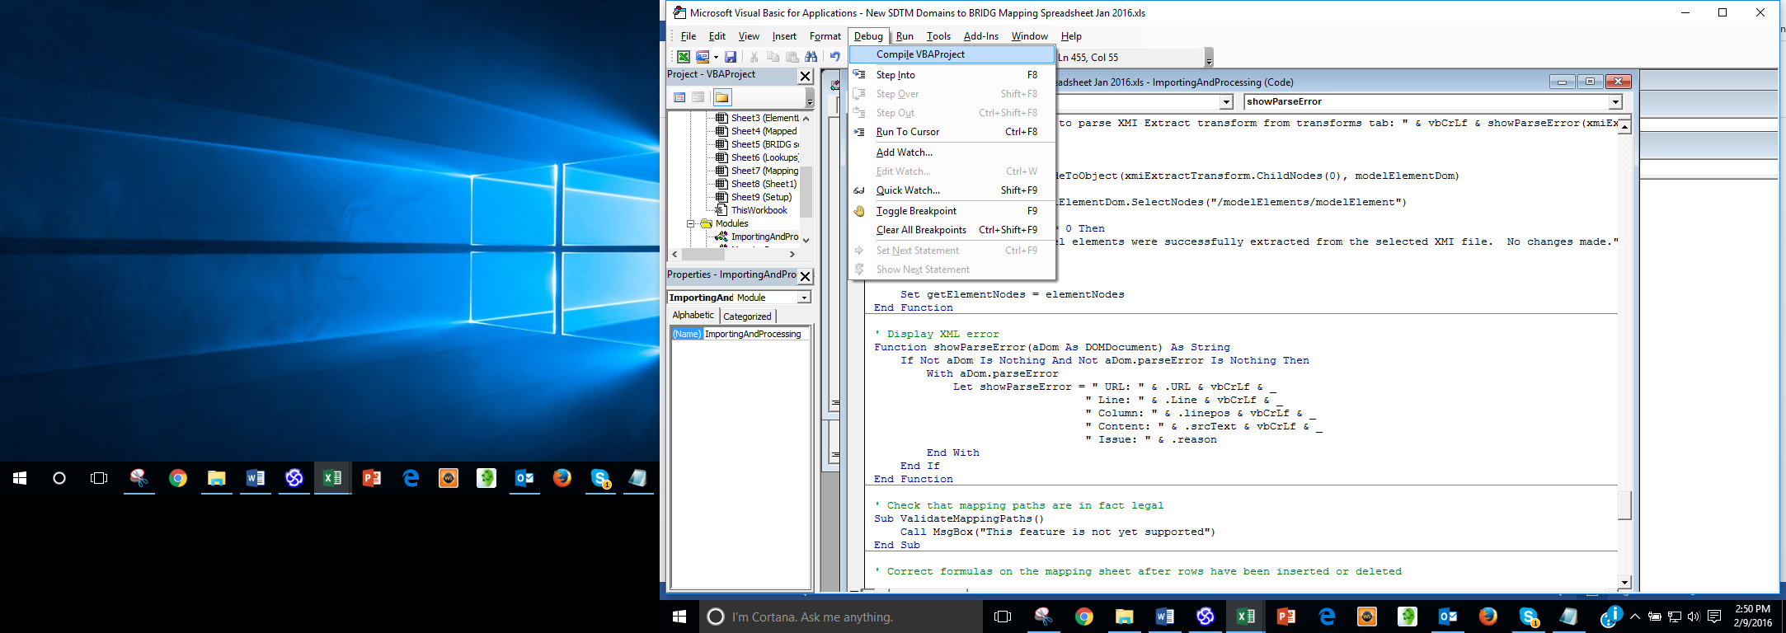

1. Then save your file. All functions in the spreadsheet should work, and the spreadsheet content should be correct.

